# **SQL DATABASE:**

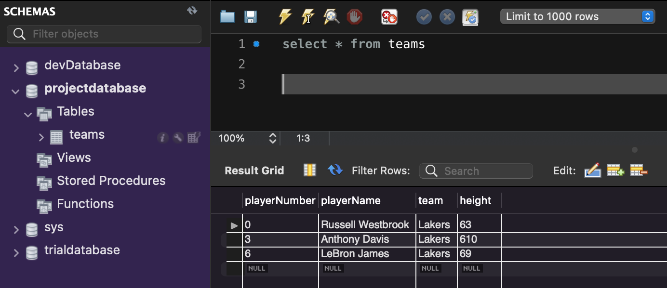

# **SWAGGER OUTPUT FOR ALLTEAMS:**

# **POSTMAN OUTPUT FOR ALLTEAMS:**

# **SUCCESSFUL JUNIT TESTING:**

# **TESTING COVERAGE 72.2%:**

